# Hope Logo

|  |
| --- |
| **Agresso 5.7**  **Web Reporting**  **User Guide** |

|  |  |
| --- | --- |
| Version : | 1.0 |
| Date : | August 2015 |
| Author: | Linda Downes |
| Email: | Downesl@hope.ac.uk |

Contents

Table of Contents

Contents

Contents

1

1. Reports available on the web 3

2. Reporting: General Information 4

2.1 Accounting periods 4

2.2 Currency amounts 4

2.3 Parameters 4

2.4 Exporting a report to Excel 4

3. Which Report to Run? 6

4. Management Reports 7

4.1 Committed Expenditure 7

4.2 Orders by Project 8

4.3 Transactions for cost centre 9

4.4 Variance Report (SMT) 10

4.5 Approved Workflow Journals by Cost Centre 11

4.6 Valid Code Combinations 12

5. Purchase Reports 13

5.1 Goods Delivery Status 13

5.2 Quick Invoice/Order Search 14

5.3 Supplier Address List 15

5.4 Supplier Payment Check 16

5.5 Supplier Requisition Enquiry 17

6. Sales and Customer Reports 18

6.1 Customer Address Search 18

6.2 Customer Invoices and Payments 19

6.3 KX Invoices and Payment Dates 20

7. Project Reports 21

7.1 Project Report 21

7.2 Active Project Forms Workflow/ Historical Project Forms Workflow 22

# Reports available on the web

Reports will be placed in one of the folders within the Reports section of Agresso. They can be run at any time and will always give ‘real time’ information as they interrogate the Agresso database at the time they are run to retrieve the latest information.

The menu route is Reports » Global Reports » Web Reports

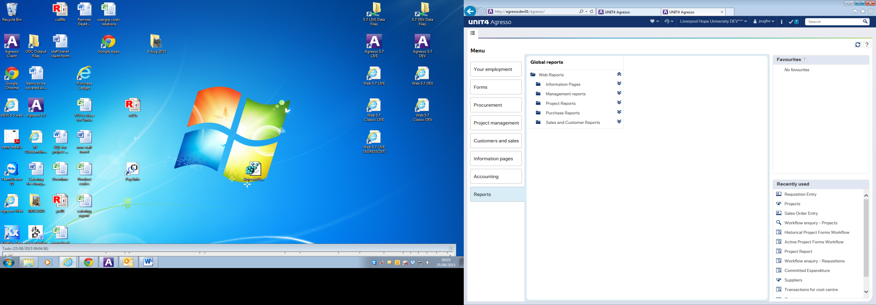

All reports have at least one prompt when running them allowing you to select a specific cost centre or project for which to run the report. If nothing is entered here the report will return all data for the accounts, cost centres and projects to which you have access.

New reports can be written as required. If the information you need to monitor a particular budget is not readily available, please contact Linda Downes.

# Reporting: General Information

## Accounting periods

The financial year is divided into 12 accounting periods, one for each calendar month. It starts in August and runs to the following July.

Some reports prompt for the accounting period(s) for which they are to be run. The period is entered in the format YYYYMM, where YYYY is the year in which the accounting year started and MM is the month starting with 01(August), 02 (September) etc until July which is month12.

For example, in the accounting year running from August 2015 until July 2016, August 2015 is 201501, September 2015 is 201502, through to 201512 which is July 2016.

## Currency amounts

Where an order is raised in a currency other than GBP, the GBP amounts will only be an approximate value. This is because we do not update the rate of exchange for every currency on a regular basis, so Agresso will use the latest rate held. **However, when the invoice is paid, we use the rate supplied by Western Union at the time of the payment, so the amount your cost centre or project is debited will be correct.**

## Parameters

Most reports have prompts which may be entered to determine the information that is returned on the report. Any combination of these may be entered.

Once the report has run, you can change the parameters in the Selection Criteria section then click on the search button to re-run the report with the new criteria.

## Exporting a report to Excel

Once a report has been run, it can be exported to Excel for further analysis. To do this, click on the Export button at the bottom of the screen. Then click on Export – Browser.

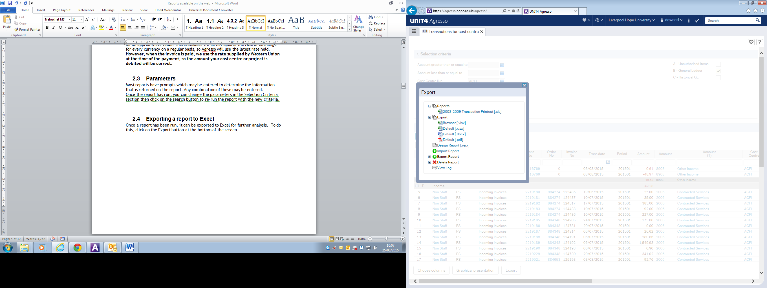

You may then get a message to confirm opening of the report:

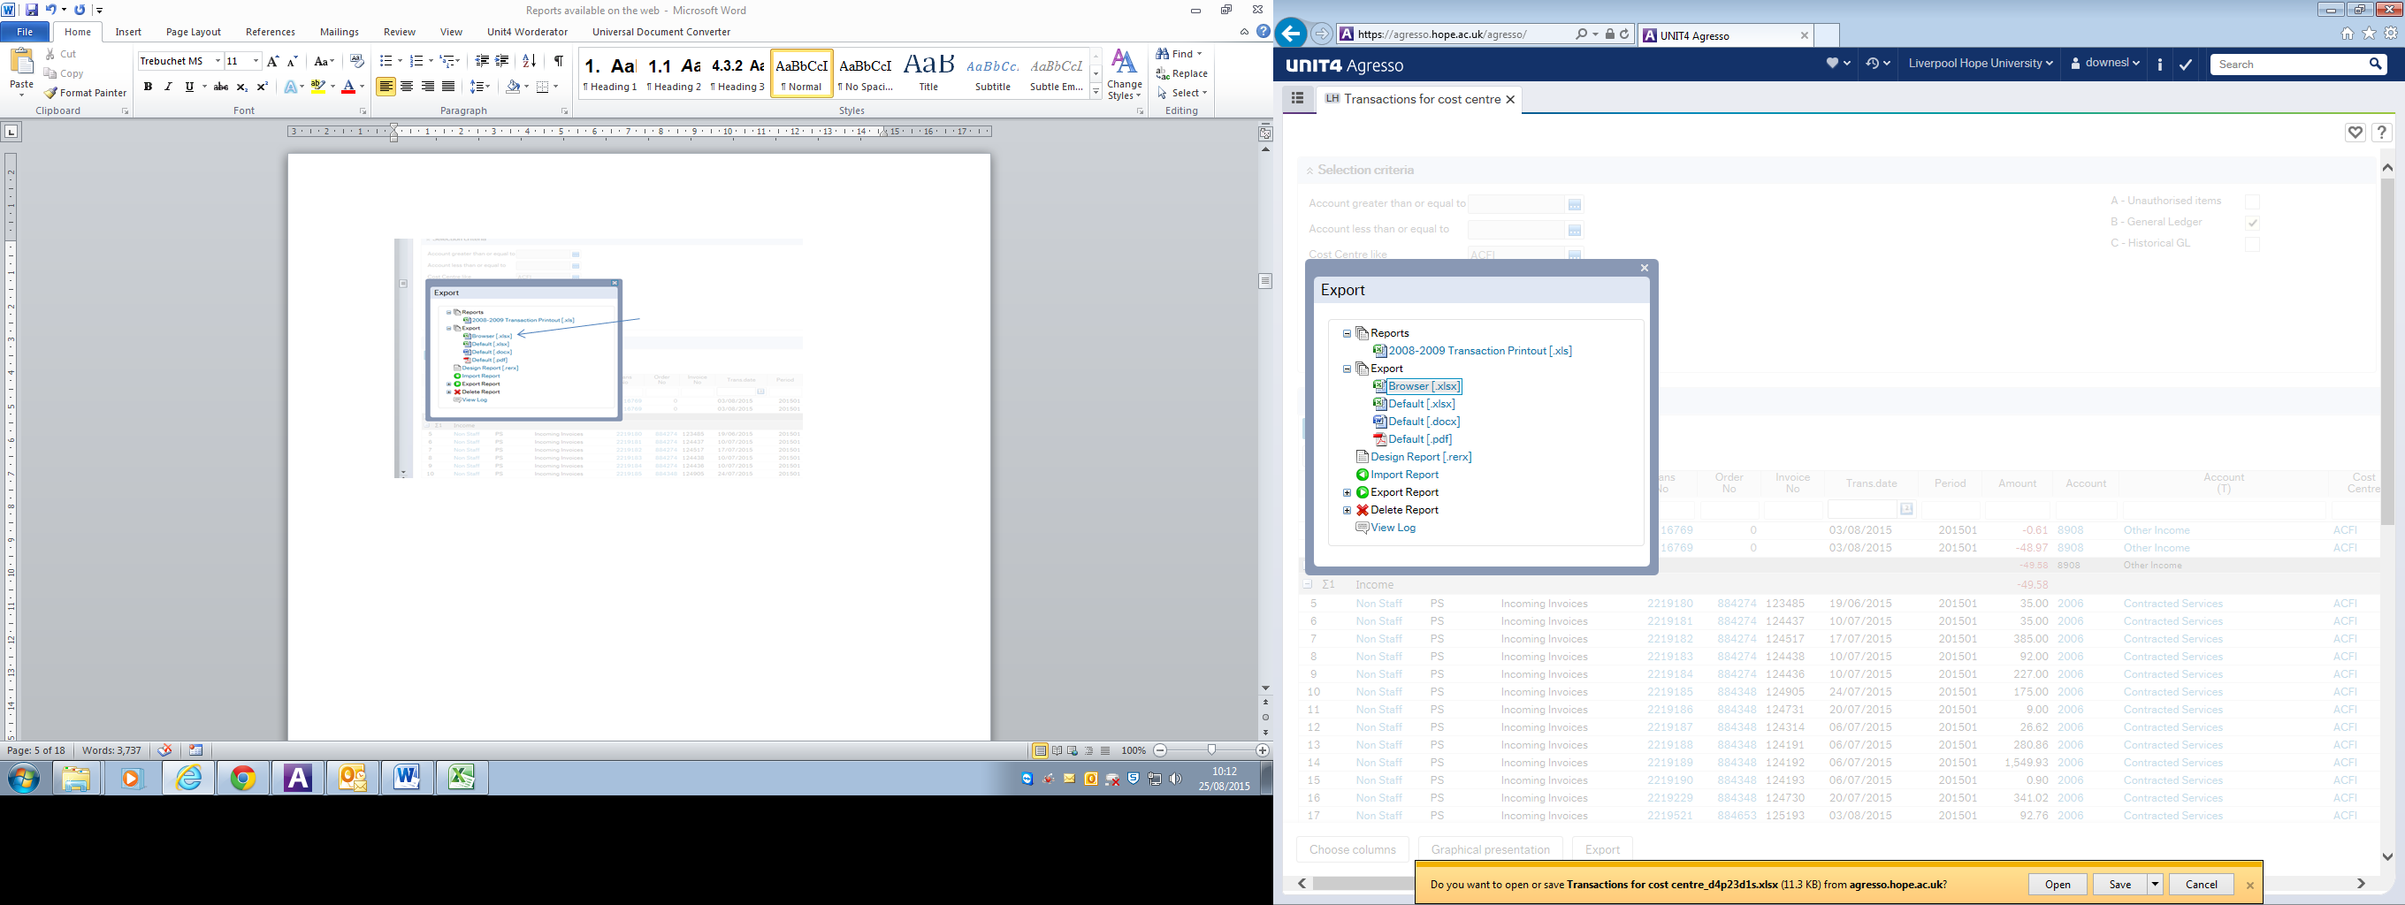

Click on Open to open the spreadsheet.

# Which Report to Run?

You want to see:

|  |  |  |
| --- | --- | --- |
| Information about your budget, what has been spent so far and what is left | Variance Report (SMT) | 4.4 |
| Details if the transactions which have gone through your cost centre/project | Transactions for Cost Centre | 4.3 |
| Your future commitments – Purchase orders which have been approved but are still awaiting payment | Committed expenditure | 4.1 |
| A list of the GL Journals which have been approved and which will debit or credit your cost centre/project | Approved workflow journals by cost centre | 4.5 |
| Whether an account code or project code is valid for a cost centre | Valid code combinations | 4.6 |
| A list of all the requisitions/purchase orders raised for a particular project | Orders by Project | 4.2 |
| A list of all purchase orders for your cost centre/project which have not yet been goods received | Goods Delivery Status | 5.1 |
| Which order was used for a particular invoice or vice versa | Quick invoice/Order search | 5.2 |
| The address for one or more suppliers | Supplier Address List | 5.3 |
| Whether a supplier invoice has been paid | Supplier Payment Check | 5.4 |
| All the requisitions raised for a particular supplier, showing the coding used | Supplier Requisition Enquiry | 5.5 |
| The address for one or more Customers | Customer Address List | 6.1 |
| Whether a customer has paid their invoice(s)  (Invoices originated from a sales order) | Customer invoices and payments | 6.2 |
| The cost centre and project credited by a sales invoice | Customer invoices and payments | 6.2 |
| Whether a customer has paid their invoice(s)  (Invoices originated from the KX system) | KX invoices and payment dates | 6.3 |
| Where a Project Application form is in the workflow and who has approved it so far | Active Project forms Workflow | 7.2 |
| The route of a completed project application and who approved/rejected it at each step | Historical Project Forms Workflow | 7.2 |

# Management Reports

## Committed Expenditure

This report shows all orders which have been approved by a budget holder but which have not yet been matched to invoices and paid. The actual expense is therefore not reflected in the other reports such as the cost centre report and variance report as it has not yet materialised. This report should be checked regularly as it shows expenses which are expected in the future and will therefore affect the budget.

If any orders are shown on the Committed Expenditure report which are known to be obsolete (i.e. the order was never placed with the supplier, the order is a duplicate or the invoice was settled by card), please contact Finance so the order can be closed and therefore removed as an outstanding commitment.

There are 4 prompts which may be entered when running this report. You can leave any or all of these blank to view commitments for the accounts/cost centres and projects to which you have access. Alternatively, you can enter any of the following information:

|  |  |
| --- | --- |
| Prompt |  |
| Account like | You can enter an account code here if you wish to view the commitments for one account only. Alternatively, leave this blank to view commitments for all accounts matching the other search criteria. |
| Cost centre like | The cost centre for which you wish to view the outstanding commitments |
| Project like | The project for which you wish to view the outstanding commitments |

The report shows:

|  |  |
| --- | --- |
| Heading |  |
| Order number |  |
| Currency Amount/Currency | The amount of the order line in the original currency and the original currency code |
| Approved Date | Date the order line was approved by the budget holder |
| Goods Received Date | Date the order line was goods received. This may be blank if the order has not been goods received yet. |
| Account, cost centre and project |  |
| Supplier | The supplier code and name |
| Product | The product code used on the order |
| Value Goods received | The amount of the line which has been received |
| Value still to invoice | The amount of the line which has not yet been invoiced and which is therefore still a commitment. |
| Requisitioner |  |

## Orders by Project

This report is designed to show the requisitions raised against a project with the dates that they were initially entered onto Agresso and subsequently approved.

There are 4 prompts which may be entered when running this report. You can leave any or all of these blank to view orders for the projects to which you have access. Alternatively, you can enter any of the following information:

|  |  |
| --- | --- |
| Prompt |  |
| Project | The project code for which you wish to view orders. The project code is 8 characters long, usually 3 alpha and 5 numeric |
| Period Greater than or Equal to/  Period Less than or Equal to | The start and end point for the report. The period is entered in the format YYYYMM (see section 2.1). These can be left blank to see all orders, or the start or end point, or both, may be entered. |
| Order No like | To view a particular order, enter the order number here. Alternatively, leave this field blank to view all orders. |

The report shows:

|  |  |
| --- | --- |
| Heading |  |
| Period | Period in which the requisition was entered onto Agresso |
| Order Number |  |
| Cost centre and project |  |
| Date Requested | Date the requisition was entered |
| Date Approved | Date requisition was approved by the budget holder |
| Requested by | Requisitioner |
| Supplier |  |
| Amount requested/Currency | Amount of the order line in the original currency |
| Amount requested (GBP) | Approximate value, in GBP, of the order line amount. See section 2.2 |
| Tax Amount | The amount of tax invoiced so far |
| Amount invoiced | The amount in GBP which has been invoiced so far |
| Amount remaining | The amount of the order line which is still outstanding. |

## Transactions for cost centre

This report shows all the transactions which have posted to the financial ledgers for your cost centre, for one or a range of periods. The information shown will include purchase invoices, sales invoices and any internal transfers.

The prompts when running this report are listed below. Any one or more may be entered.

|  |  |
| --- | --- |
| Prompt |  |
| Account greater than or equal to/  Account less than or equal to | To view the transactions for one account code only, or a range of accounts, enter the codes here. Alternatively leave this blank to view all accounts to which you have access |
| Cost centre like | To view the transactions for one cost centre only, enter the cost centre code here. Alternatively leave this blank to view all cost centres to which you have access |
| Project like | To view the transactions for a specific project, enter the project code here |
| Period Greater than or Equal to/  Period Less than or Equal to | The start and end point for the report. The period is entered in the format YYYYMM (see section 2.1). The default start period is the start of the current year but this can be amended. These prompts can be left blank to see all transactions, or the start or end point, or both, may be entered. |

For the criteria entered, the report will show:

|  |  |
| --- | --- |
| Heading |  |
| Class | The report is divided into 3 sections: income, staff costs and non-staff costs. |
| Trans Type | The Transaction type and description, the most common being:  PS = purchase invoice  GL=General Ledger journal transfer,  GS = transaction from on-line store  SO=Sales invoice |
| Trans No. | Transaction number automatically generated by Agresso when item is posted to the ledger |
| Order No. | Purchase order number, if applicable |
| Invoice No. |  |
| Trans Date | Invoice date or journal transfer date |
| Period | Accounting period the item was posted to. See section 2.1 |
| Account/Cost centre/Project |  |
| Text | A narrative entered against this item. |
| Customer/supplier |  |
| TC | Tax code, one of:  PE (purchase exempt), PZ (Purchase zero rated), PS (purchase standard 20% rate), SE (sales exempt), SZ (Sales zero rated), SS (sales standard 20% rate) |

## Variance Report (SMT)

This report shows the actual expenditure/income for a cost centre along with the budget for each account code. The report is ordered with income first, followed by staff costs and finally, non-staff costs.

The report shows the total balance for each account/cost centre/project and period but not the transaction details which make up that balance. This information is available on the Transactions for Cost Centre report. Alternatively, click on a balance figure to view the transaction details from which the balance is derived.

The prompts when running the report are:

|  |  |
| --- | --- |
| Prompt |  |
| Cost centre like | To view the balances for one cost centre only, enter the cost centre code here. Alternatively leave this blank to view all cost centres to which you have access |
| SMT Area like | The report can be run to include all cost centres to which you have access, based on the SMT area they fall into, rather than entering multiple cost centres as a range. All cost centres selected will be shown on the same report. The SMT areas currently are:  ATSHUM – Arts & Humanities Deanery  AVCEXT – AVC External Relations  AVCLA - AVC Legal & Administration  AVCR – AVC research  AVCSRM – AVC Strategic resource and Management  AVCSSW – AVC Student Support & Wellbeing  SCIENCE – Sciences and Social Sciences  BUSINESS - Business & Computer Sciences Deanery  EDUCATION - Education Deanery  OTHER |
| Period greater than or equal to/  Period less than or equal to | The start and end point for the report. The period is entered in the format YYYYMM (see section 2.1). The default start period is the start of the current year but this may be amended. Leave the end period blank to see all transactions from the start point onwards, otherwise enter an end period. |
| Project like | To view the balances for a specific project, enter the project code here |

For the criteria entered, the report will show:

|  |  |
| --- | --- |
| Heading |  |
| Class | The report is divided into 3 sections: income, staff costs and non-staff costs. |
| SMT area | The SMT area for this cost centre |
| Account |  |
| Cost Centre/project |  |
| Period | The financial period |
| Amount | The balance for this account/cost centre/project and period |
| Committed | The total of any outstanding orders for this account/cost centre/project and period |
| Budget to Date | The budget for this account/cost centre/project and period |
| Under/Over Spend |  |

## Approved Workflow Journals by Cost Centre

This is a report to show the GL journals which have been approved for a particular cost centre/project.

**NB: It does not show journals which are still in the workflow awaiting approval, only those which have been approved.**

Some GL journals, such as those for catering, conferencing, telephone and reprographic recharges do not go through the workflow and therefore will not be shown on this report. The report will, however, show journals which have been automatically approved as the budget holder has not approved or rejected them within the 5 day window the budget holder has to action the journal.

By default, the report will run for the current financial year. To see journals for previous years, you will need to change the ‘period greater than’ or ‘period less than’ prompts.

|  |  |
| --- | --- |
| Prompt |  |
| Period greater than or equal to | By default, this is the opening period of the current year but may be changed |
| Period less than or equal to | By default, this is the closing period of the current year but may be changed |
| Cost centre |  |
| Project |  |

The report will show all approved GL journals which match the selection criteria and which have been approved via the workflow.

For each one, it will show:

|  |  |
| --- | --- |
| Heading |  |
| Trans No | The transaction number |
| Entered onto Agresso | Date the journal was first entered |
| Posted | Date the journal was finally approved and posted into Agresso to update the balances for the cost centre/project |
| Period |  |
| Account/ cost centre / Project |  |
| Text | Narrative that was entered as a description at the time the journal was first entered |
| Amount | The amount posted to this account/cost centre and project. A debit is presented as a positive amount, a credit as a negative. |

## Valid Code Combinations

This report will show all the valid account and project combinations for a cost centre or all the account and cost centre combinations for a particular project. It will only show projects which are current (i.e. have not passed their end date) and which have a status of ‘active’. Any closed or terminated projects will not be shown.

The only prompts are for a cost centre and/or a project. Either may be entered. If both are left blank, the report will show ALL valid account/cost centre/project combinations.

The report will show:

|  |  |
| --- | --- |
| Heading |  |
| Cost centre | Cost centre code and description |
| Account | Account code and description |
| Project | Project code and description |

# Purchase Reports

Currently, there are several reports available in the purchase reports folder. More may be added if required.

## Goods Delivery Status

This enquiry shows you all outstanding orders for your cost centre(s) which have not yet been goods received.

Since this enquiry shows the quantity ordered, quantity delivered so far and quantity still to be delivered it can be used to track order lines which have not yet been goods received. Once an order line has been fully goods receipted, it will no longer appear on the report.

The prompts when running the report are:

|  |  |
| --- | --- |
| Prompt |  |
| Cost centre | To view the undelivered orders for one cost centre only, enter the cost centre code here. Alternatively leave this blank to view all cost centres to which you have access |
| Project | To view the undelivered orders for one project only, enter the project code here. Alternatively leave this blank to view all projects to which you have access |

The report will display the following information:

|  |  |
| --- | --- |
| Heading |  |
| Order Number |  |
| Requisitioner |  |
| Order Date | Date the order was approved |
| Account/cost centre/project |  |
| Supplier |  |
| Product/description |  |
| Qty Ordered | The quantity on the order |
| Qty Delivered | The quantity which has been goods received so far |
| Qty To be delivered | The quantity which is still waiting to be goods received |
| Value still to invoice | Value still outstanding on the order |

## Quick Invoice/Order Search

This is a simple enquiry allowing you to link an order number with an invoice or vice versa, so if you know one of these pieces of information, the search will return the other. It is useful for credit notes if you need to find the order number used against the original invoice.

There are 3 prompts when running this report. Information should be entered in at least one of these prompts:

|  |  |
| --- | --- |
| Prompt |  |
| Supplier code like | You can enter a supplier code as well as an invoice number or order number |
| Invoice number like | You can enter an invoice number here to view the order which was used against it. Please note this search criteria is specific so if the invoice number is ambiguous and contains spaces or special characters, you are advised to use * as a wildcard for the ambiguous characters. |
| Order number like | Enter an order number here to see the invoice(s) this was used against. |

The report will display the following information:

|  |  |
| --- | --- |
| Heading |  |
| Supplier code/name |  |
| Order number | The PO number |
| Invoice Number |  |
| Transaction Date | Invoice date |
| Period |  |
| Text | Narrative entered against the invoice |
| Amount | Amount of the invoice |

## Supplier Address List

This report will allow you to check the address details of a supplier. There are only 2 prompts on this report - for a supplier name or postcode. If you enter a supplier name, the report does an ‘exact match’ so it is recommended that you use * before and after your search criteria. For example, to find Post Office, you could enter *POST* or *POST OFFICE* or *OFFICE*. However, if you just entered POST OFFICE the report would not find them as the Post Office is actually set up as ‘Post Office Ltd’. Alternatively, you can enter all or part of a post code. Again, you need to use * for any characters in the post code you do not enter or know. For example, L16 entered as a post code would not find any suppliers, but L16* would.

If you enter nothing at these prompts and leave them blank, the report will return all supplier’s addresses.

There are 2 prompts when running this report. Both can be left blank, or enter information at one of them:

|  |  |
| --- | --- |
| Prompt |  |
| Name Like | All or part of the name can be entered with * used to represent words not entered (see above) |
| Post code like | All or part of the postcode can be entered with * used to represent any characters not entered (see above) |

The report will display the following information:

|  |  |
| --- | --- |
| Heading |  |
| Supp ID | The Agresso supplier code |
| Name |  |
| Address/ postcode/town/city/  Telephone/email |  |

## Supplier Payment Check

This report allows you to enter an invoice number or an order number to find details of the payment made against that invoice. Alternatively, you can enter a supplier code to see all payments made to a supplier matching the other criteria entered. If the report does not return any results, it is because it cannot find the invoice number or order number that has been entered.

There are 3 prompts when running the report. At least the Invoice Number or order number should be entered:

|  |  |
| --- | --- |
| Prompt |  |
| Supplier ID like | A supplier ID code may be entered, though this is optional |
| Invoice Number like | Please note this search criteria is specific so if the invoice number is ambiguous and contains spaces or special characters, you are advised to use * as a wildcard for the ambiguous characters. |
| Order No Like | Instead of an invoice number, a purchase order number may be used to locate the payments made against an order |

The report will display the following information:

|  |  |
| --- | --- |
| Heading |  |
| Supplier ID | The supplier ID code and name |
| Invoice Number/invoice date |  |
| Date Paid | If the invoice has not been paid, this column will be blank |
| Period | Period the invoice was posted to |
| Currency Amount | Amount of the invoice in the currency of the invoice |
| Amount GBP | Amount of the invoice in GBP |
| Remaining Amount | The amount remaining to be paid on the invoice. This will be 0.00 if the invoice has been fully paid |
| Order Number | The purchase order number linked to this invoice |
| Text | The narrative against the invoice |

## Supplier Requisition Enquiry

This report shows all the requisitions which have been raised for a supplier, whether or not they have subsequently been approved by the budget holder.

There are 4 prompts when running the report. Information should be entered into at least one of them.

|  |  |
| --- | --- |
| Prompt |  |
| Requisition like | A requisition number may be entered |
| Supp code like | To view all requisitions for a supplier, the supplier ID (8 digit code) can be entered. |
| Purchase order like | To view a specific purchase order, the PO number may be entered here |
| Date entered greater to or equal to | To view all requisitions from a date, enter it here. (Entered as DDMMYYYY) |
| Cost centre like | To narrow the search and find requisitions for a specific cost centre only, enter it here |
| Project Like | To find requisitions for a specific project only, enter it here |

The report will display the following information:

|  |  |
| --- | --- |
| Heading |  |
| Workflow Status | This will be one of:   * Finished. The requisition has finished in the workflow and has an order number * Aborted. The requisition has been rejected by the budget holder and subsequently rejected by the initiator * Workflow in progress. The requisition is with the budget holder for approval or, if they have rejected it, is back with the initiator awaiting further rejection or re-submission |
| Supplier code/name |  |
| Initiator | Person who put the requisition on to Agresso |
| Requisition No. |  |
| Purchase order |  |
| Date entered. | Date the requisition was entered on to Agresso |
| Product/Description |  |
| Unit price | Price of one article |
| Ordered | Quantity ordered |
| Amount | Unit price x quantity ordered |
| Account/ cost centre/ project |  |

# Sales and Customer Reports

## Customer Address Search

This report is very similar to the Supplier Address Search, allowing you to check the address details of a customer. There are only 2 prompts on this report - for a customer name or postcode. If you enter a name, the report does an ‘exact match’ so it is recommended that you use * before and after your search criteria. For example, to find Liverpool City Council, you could enter *CITY* or *LIVERPOOL CITY* or *COUNCIL*. However, if you just entered LIVERPOOL the report would not find them. Alternatively, you can enter all or part of a post code. Again, you need to use * for any characters in the post code you do not enter or know. For example, L16 entered as a post code would not find any customers, but L16* would.

If you enter nothing at these prompts and leave them blank, the report will return all customer’s addresses.

There are 2 prompts when running this report. Both can be left blank, or enter information at one of them:

|  |  |
| --- | --- |
| Prompt |  |
| Name Like | All or part of the name can be entered with * used to represent words not entered (see above) |
| Post code like | All or part of the postcode can be entered with * used to represent any characters not entered (see above) |

The report will display the following information:

|  |  |
| --- | --- |
| Heading |  |
| Customer ID | The Agresso customer code |
| Name |  |
| Address/ postcode/town/city/  Telephone |  |

## Customer Invoices and Payments

This report allows you to search the invoices raised for a particular customer, showing the cost centre and project they were credited to, the invoice detail and the amount remaining for the customer still to pay.

**NB: The report does not show invoices raised on the Kinetics system (i.e. for conferencing and accommodation), it will only show invoices which originated from a sales order on Agresso.**

There are 4 prompts when running the report. Either the customer code, an invoice number or a sales order should be entered. The start period defaults to the start if the current academic year but can be amended if necessary.

|  |  |
| --- | --- |
| Prompt |  |
| Invoice No Like | An invoice number may be entered here to see details of one invoice only |
| Customer Like | Enter a customer code to view all invoices for them, based on the other selection criteria. |
| Sales Order no Like | A sales order number may be entered to view details of one invoice |
| Period greater than or equal to | Defaults to the start of the current financial year but this can be changed if you need to view older invoices. The format is YYYYMM (see 2.1) |

The report will display the following information:

|  |  |
| --- | --- |
| Heading |  |
| Order raised by | Initiator of the sales order |
| Customer |  |
| Invoice date | Date the invoice was raised |
| Pay date | Date the invoice was paid. If this is blank, the invoice has not been paid. |
| Sales Order No |  |
| Invoice No |  |
| Description | Description from the order |
| Cost centre/project |  |
| Curr Amount | Amount of the invoice in currency |
| Tax code | May be either :   * SS (Sales standard rate) * SZ (Sales Zero rate) * SE (Sales exempt) |
| Tax amount | Calculated using the amount and tax code |
| Invoice Amount | Amount + tax amount for line |
| Amount still to pay | Balance outstanding |

## KX Invoices and Payment Dates

This report is similar to Customer Invoices and Payments except it will only show invoices which originated in the KX system (i.e. invoices relating to accommodation and conferencing).

There are 3 prompts when running the report. Either the customer code, an invoice number or a booking reference should be entered.

|  |  |
| --- | --- |
| Prompt |  |
| Customer ID Like | Enter a customer code to view all invoices for them, based on the other selection criteria. |
| Invoice No Like | An invoice number may be entered here to see details of one invoice only |
| Booking Ref like | A booking reference may be entered to see the invoice for one particular booking |

The report will display the following information:

|  |  |
| --- | --- |
| Heading |  |
| Customer code and name |  |
| Invoice number |  |
| Invoice Date |  |
| Due Date | Date the invoice is due to be paid |
| Pay date | Date the invoice was paid. If this is blank, the invoice has not been paid in full. |
| Amount |  |
| Remaining amount to pay |  |
| Booking Ref | The booking reference and brief description |

# Project Reports

## Project Report

The Project report is similar to the Transactions for Cost Centre report but by default will show all transactions for a project regardless of period. It can, however, be run for a single period or a range of periods by entering these in the relevant prompts.

The transactions are ordered by nominal account with a total at the end of each account.

There are 4 prompts when running the report. You must enter either a project or cost centre or both. If a project has run in more than one cost centre, leaving the cost centre blank will show all transactions for the project regardless of cost centre providing you have access to them.

|  |  |
| --- | --- |
| Prompt |  |
| Project Like |  |
| Cost centre like |  |
| Period greater than or equal to/ Period less than or equal to | By default the report runs for all periods but a start and end period may be entered. See section 2.1 for information on accounting periods. |

The report will display the following information:

|  |  |
| --- | --- |
| Heading |  |
| TT | The Transaction type and description, the most common being:  PS = purchase invoice  GL=General Ledger journal transfer,  GS = transaction from on-line store  SO=Sales invoice |
| Trans No | A system generated number created when the transaction is posted to Agresso |
| Trans Date |  |
| Period |  |
| Account/ cost centre/ project |  |
| Text | For GL journals this is the narrative that was entered as a description at the time the journal was first entered. For other transactions it may have been manually entered or taken from the sales order/purchase order |
| Amount |  |
| Customer / Supplier |  |
| Order No. | Sales or purchase order number |
| Invoice No. |  |

## Active Project Forms Workflow/ Historical Project Forms Workflow

These 2 enquiries are intended to show the progress of a project application through the workflow. Projects are initially entered as a Form with all the supporting information. If the Form is approved at every stage a project is created at the end.

If the Form has already completed the workflow (and a project created) you need to use the ‘Historical Project Forms Workflow’ whilst the ‘Active Project Forms Workflow’ shows those forms which are still awaiting approval.

The only prompt when running the report is the Project ID.

The report will show:

|  |  |
| --- | --- |
| Heading |  |
| Description | This is the step in the workflow |
| Initiator | Person who entered the form |
| Action Code | Action taken at this step in the workflow |
| Comments | Any comments entered by the approver when the project was actioned by them |
| Project ID |  |
| Processed By | Person who approved/rejected the project at each step |
| Project Title |  |
| Task Sent/ Task Completed | Date the task was sent to the approver and date it was actually actioned |